**THISAI Bookshop – Detail**

**Technical Analysis of the Financial Markets: A Comprehensive Guide to Trading Methods and Applications - John J. Murphy**

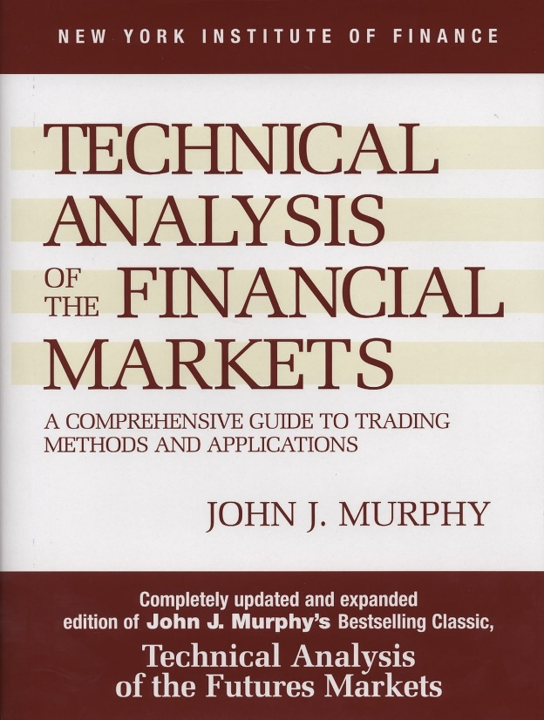

**Japanese Candlestick Charting Techniques - Nison Steve**

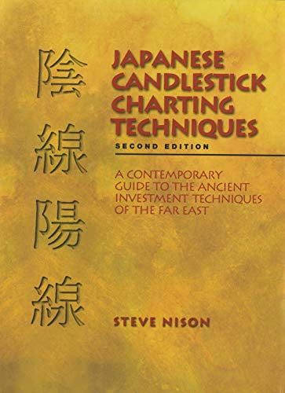

**THE SILENT PATIENT [Paperback] - Alex Michaelides**



**It Starts With Us [Paperback] Kunex -COLEEN HOOVER**

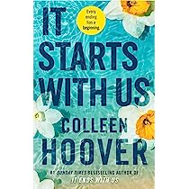

**Kunex It Ends With Us : ''Sometimes The One Who Loves You Is The One Who Hurts You The Most'' - COLEEN HOOVER**



**6 Never Split the Difference: Negotiating as if Your Life Depended on It - Chris Voss**

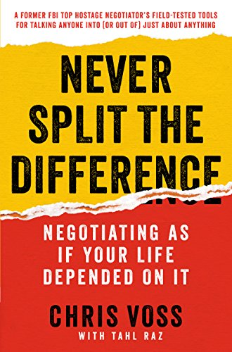

**The Palace of Illusions: 10th Anniversary Edition [Paperback] Banerjee Divakaruni, Chitra - Chitra Banerjee Divakaruni**

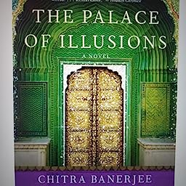

**Ocean of Churn : How the Indian Ocean Sh: How the Indian Ocean Shaped Human History - Sanjeev Sanyal**

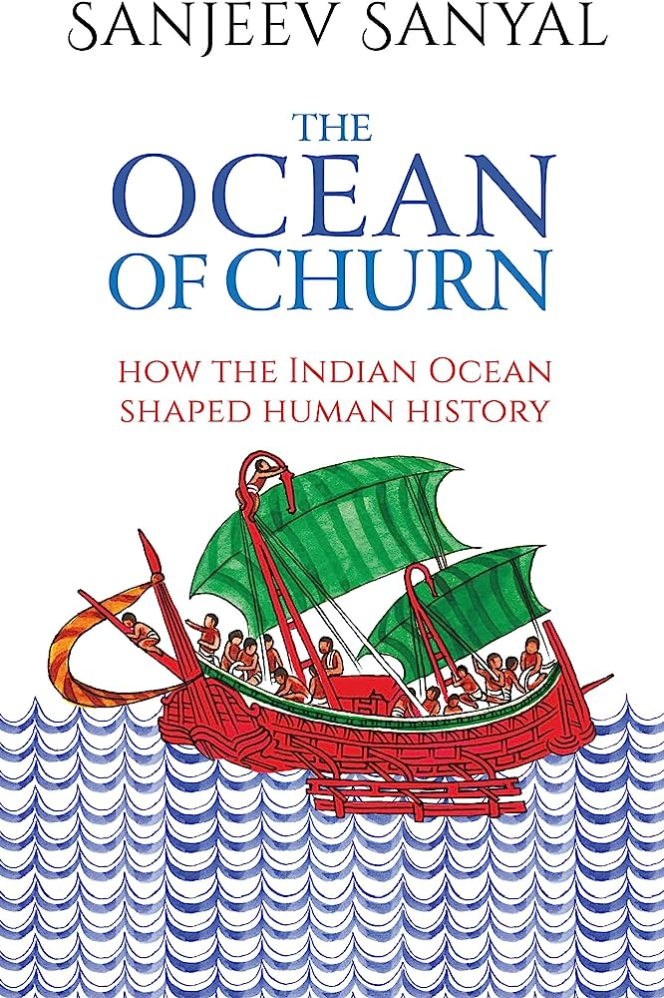

**Atomic Habits: the life-changing million-copy #1 bestseller - James Clear**

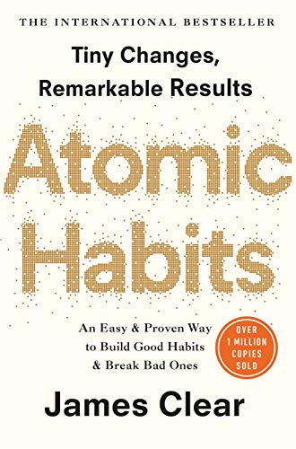

**Do Epic Shit - Ankur Warikoo**

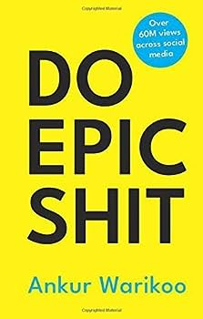

**A Thousand Splendid Suns - Khaled Hosseini**



**THE AMERICAN ROOMMATE EXPERIMENT - Elena Armas**



**The Kite Runner - Khaled Hosseini**

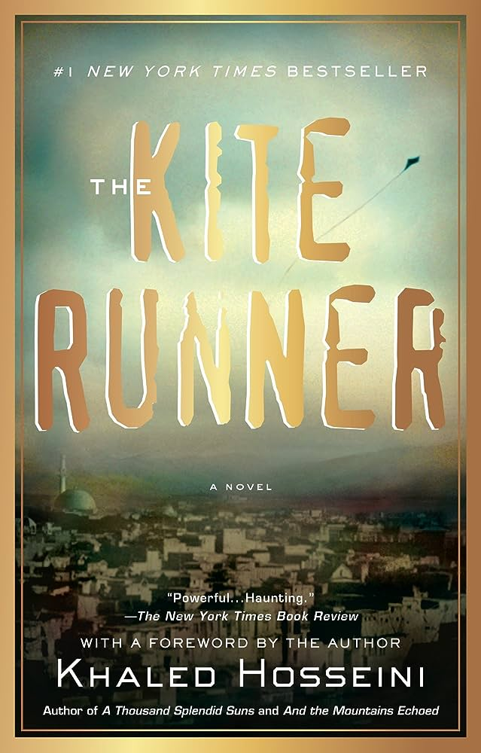

**Lean In: Women, Work, and the Will to Lead [Paperback] Sandberg, Sheryl - Sheryl Sandberg**

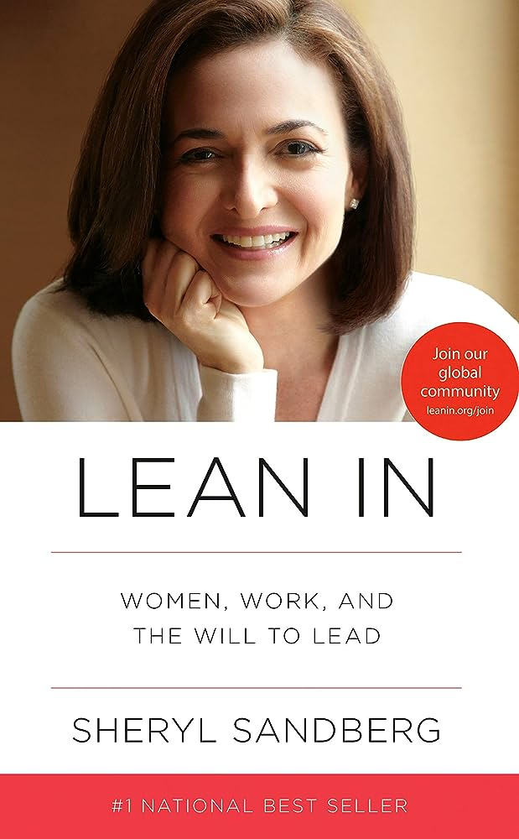

**Culture Code: The Secrets of Highly Successful Groups - Daniel Coyle**

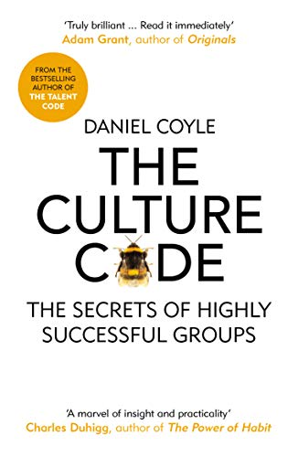

**Read People Like a Book: How to Analyze, Understand, and Predict People's Emotions, Thoughts, Intentions, and Behaviors - Patrick King**

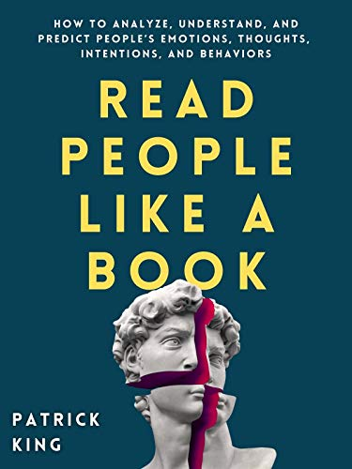

**Surrounded by Idiots - Thomas Erikson**

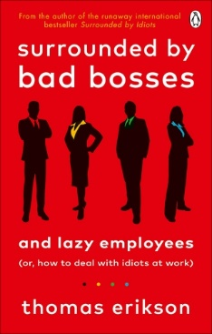

**Getting Over You - Kunex**



**Master Your Emotions: A Practical Guide to Overcome Negativity And Better Manage Your Feelings - Thibaut Meurisse**

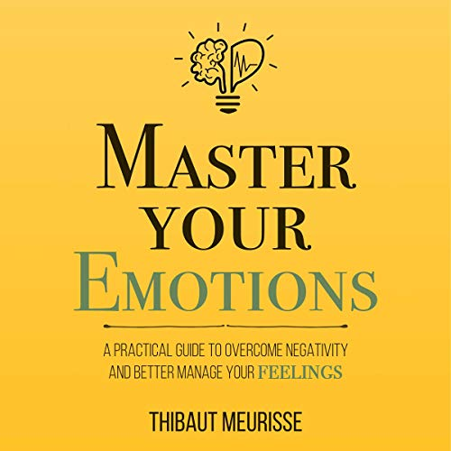

**Talk Like TED: The 9 Public Speaking Secrets of the World's Top Minds - Carmine Gallo**

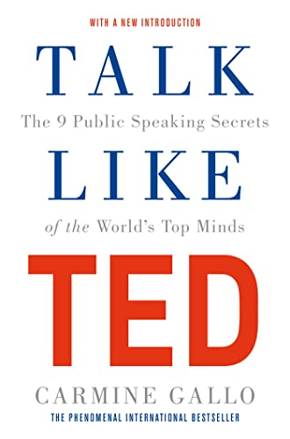

**The 7 Habits of Highly Effective People Paperback – 1 January 2019 - Stephen R. Covey**

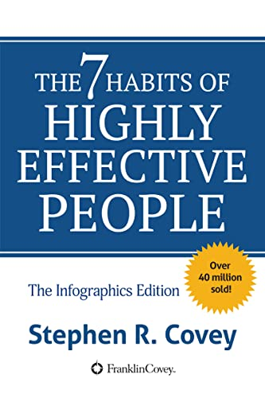

**Lighter: Let Go of the Past, Connect with the Present, and Expand The Future - Yung Pueblo**



**Never Never The Complete Series Paperback by Colleen Hoover Latest Edition - Colleen Hoover**



**8 Rules of Love : How to Find it, Keep it, and Let it Go: From Sunday Times No.1 bestselling author Jay Shetty, a new guide on how to find lasting ... from the author of Think Like A Monk**

* **Jay Shetty**



**Surrounded by Psychopaths: or, How to Stop Being Exploited by Others - Thomas Erikson**

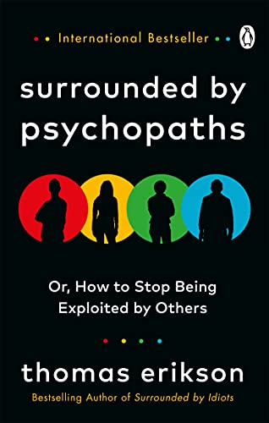

**Dopamine Detox. (Original Imported Book) - Thibaut Meurisse**

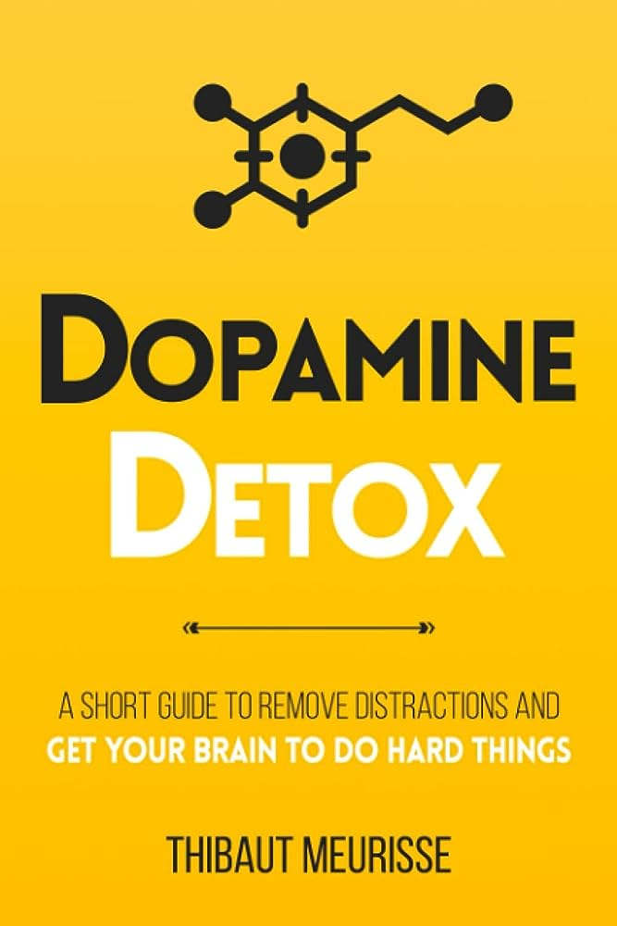

**As a Man Thinketh - James Allen**



**Three Thousand Stitches: Ordinary People, Extraordinary Lives [Paperback] Murty, Sudha**

* **Sudha Murty**

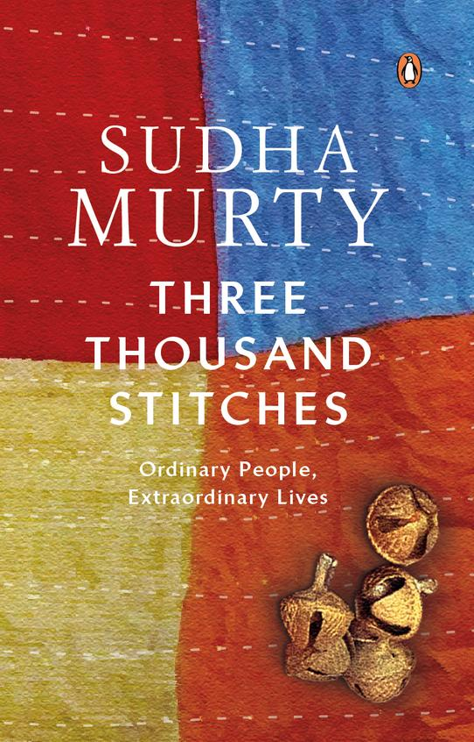

**Here,There and Everywhere : Best-Loved - Sudha Murty**

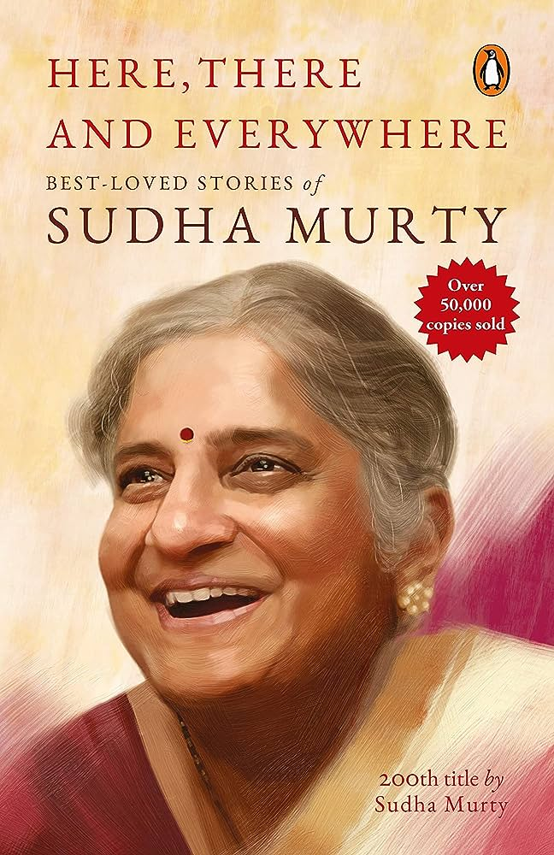

**The Daughter from a Wishing Tree: Unusual Tales about Women in Mythology [Paperback] Murty, Sudha**

* **Sudha Murty**

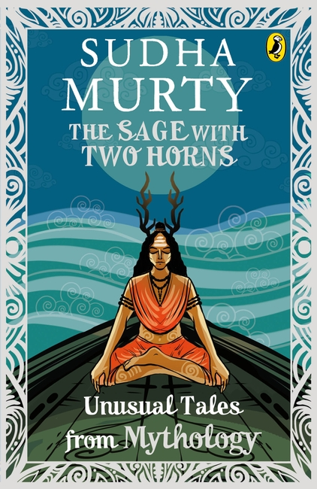

**The Serpent's Revenge: Unusual Tales from the Mahabharata [Paperback] Sudha Murty**

* **Sudha Murty**

